**ANL488 FINAL PROJECT REPORT**

**SPATIO-TEMPORAL ANALYSIS OF PUBLIC SENTIMENT IN EUROPE AND THE USA ON LOW-CARBON ENERGY SOURCES**



**Submitted by**

**CALEB CHIA WE KEAT**

**SCHOOL OF BUSINESS Singapore University of Social Sciences**

**Presented to Singapore University of Social Sciences in partial fulfillment of the requirements for the**

**Degree of Bachelor of Science in Business Analytics**

**2022**

**Abstract**

Burning fossil fuels is the largest contributor to greenhouse gas emissions in the United States. One mitigating solution to burning fossil fuels for energy is the adoption of low-carbon energy sources. However, public willingness and active involvement are key determinants in the adoption of low-carbon energy sources. Thus, this study analyses public sentiment towards low-carbon energy sources in the United States and Europe by using data from social media. Twitter, in particular, enables the evaluation of public sentiment across space and time through geotagged tweets, which provides geographic coordinates and timestamps. In this study, we collect Twitter data over a one-year period to conduct volume analysis and sentiment analysis to gain deeper insights on discussions surrounding low-carbon energy sources. Volume analysis showed that spikes in tweet volume was in correspondence to significant real-world events that such as the COP26 and the Russia-Ukraine war. Sentiment analysis was then conducted using VADER – a robust unsupervised, lexicon-based model that is specifically attuned to handle sentiments expressed in social media content. Sentiment analysis showed that the public sentiment is positive both in Europe and in the United States. We also extracted frequent keywords in positive and negative tweets which highlight topics of importance to the public. In the United States, the word ‘climate’ was used a lot in positive discussions surrounding President Joe Biden’s climate and energy bill and how it can drive decarbonisation. In Europe, the word ‘price’ appeared frequently in negative tweets with discussions on the energy crisis and high gas prices. Tweets with ‘price’ also showed discontent with prices for green energy adoption and users being unable to adopt low-carbon energy sources as a result. This study provides vital information for governments and international organisations like the United Nations to design better adoption strategies and low-carbon emission policies or initiatives.

TABLE OF CONTENTS

Chapter 1: Introduction 1

Chapter 2: Literature Review 4

2.1 Twitter as a Source for Environmental Studies 5

2.2 Sentiment Analysis 7

2.3 Applications of Sentiment Analysis and Environmental Studies 9

Chapter 3: Data Understanding and Preparation 11

3.1 Data Collection 11

3.2 Data Understanding 13

3.3 Data Preparation 15

3.3.1 Removing Duplicates 15

3.3.2 Cleaning Tweet Texts 16

3.3.3 Cleaning Location Data 17

Chapter 4: Modelling and Analysis/Discussion 19

4.1 Modelling 19

4.2 Volume Analysis 22

4.3 Sentiment Analysis 27

4.3.1 Sentiment Proportion 27

4.3.2 Word Frequency 28

4.3.3 US Analysis by State 33

4.3.4 Europe Analysis by Country 36

Chapter 5: Recommendations 37

Chapter 6: Conclusion 39

References 41

# Chapter 1: Introduction

Secretary-General of the United Nations (UN), António Guterres, made a profound statement that “making peace with nature is the defining task of the twenty-first century” (United Nations, 2020). Climate change has been one of the most prominent issues in recent decades, sparking contentious debates across the globe as growing emphasis is placed on protecting and restoring our planet. Every aspect of human lives – food, water, ecosystems, living environments, and health – are directly and indirectly tied to and impacted by the earth’s climate. Despite this, human activities are the predominant contributors to the rapid degradation of the environment. Over the last 150 years, human activities were responsible for almost the entire increase in greenhouse gases (United States Environmental Protection Agency, 2022). In the United States (US), the burning of fossil fuels was the largest contributing source of greenhouse gas emissions from human activities (United States Environmental Protection Agency, 2022).

One mitigating solution to burning fossil fuels for energy is to adopt low-carbon energy sources which enable energy generation with reduced amounts of carbon emissions. Low-carbon energy encompasses renewable, green, and clean energy sources. Green energy has a zero-emissions profile and provides the highest environmental benefit; thus, green energy can be classified as a subset of renewable energy as shown in Figure 1. Renewable energy is energy that is produced from natural sources, such as wind and sunlight, which replenish themselves faster than they are consumed and thus, produces much lower emissions compared to burning fossil fuels (United Nations, n.d.). There have been ongoing debates regarding the subtle differences between green and renewable sources. One area of contention is whether a hydroelectric dam, which diverts waterways and impacts the local environment, can really be considered ‘green’ energy. As the local environment would be impacted by a hydroelectric dam, by definition, we would consider it as renewable energy rather than green energy for this study. Clean energy, on the other hand, comes from sources which do not generate any greenhouse gases during its production. Although clean energy sources do not emit greenhouse gases, the main difference is that it is not necessarily renewable and may still negatively impacting the environment – unlike green energy sources. For instance, some forms of bio-gas sources like manure, household waste, or organic matter which may not always be completely renewable but are regarded as clean energy sources. Another example of clean energy is nuclear energy, which is considered clean as it does not produce greenhouse gases, but nuclear energy is not considered green as it requires mining, extraction, and long-term radioactive waste storage which negatively impacts the surrounding environment. How we considered low-carbon energy sources is illustrated in Figure 1. For this study, we look at low carbon-producing energy sources as a whole because it requires gradual transition and it may not be viable to fully transition to green energy in some regions due to geographic limitations.

Figure 1: Low-Carbon Energy Sources

The successful implementation of greenhouse gas mitigations like low-carbon energy sources is highly dependent on the public’s willingness and active involvement in adapting energy consumption behaviours (Zhang et al., 2022). The public’s views and opinions on low-carbon energy development benefits and burdens hold valuable insights that influence their decision making to adopt low emission sources. This information will be vital to corporations, governments, policymakers, and international organisations like the UN, which can tap on the knowledge of public preferences and perceptions to design better adoption strategies and low-carbon emission policies (Zhang et al., 2022). As such, public support and acceptance for low-carbon energy are crucial determinants for the low-carbon energy transition (Kim et al., 2021).

In today’s digital age, a large portion of people’s social interactions are shifted online. Social media has become an important platform for people interact, shared ideas, raise awareness, and find a sense of belonging with likeminded communities. Thus, social media has also become an increasingly popular tool to collect and analyse data for research that involves understanding communications amongst online users (Zhang et al., 2022). Using social media to understand public perception curbs the selection and response biases that may arise from traditional data collection methods like surveys and interviews which tend to be localised (Kim et al., 2021). For instance, people who have more interest in the low-carbon energy transition are more likely to respond for interviews and surveys, and this may yield bias in the data collection process (Kim et al., 2021). Furthermore, social media offers massive data volumes which would usually require a lot of time and costs to collect the same amount of data through conventional means. Of the various social media platforms, Twitter is a popular platform where users interact and has been increasingly used by researchers to analyse public opinion as it favours opinion sharing and is useful for the extraction of public opinion in social media (Reyes-Menendez et al., 2018). Platforms like Facebook have limitations with semi-private and private groups and profiles, whereas Twitter allows users to share opinions in a manner that is the most accessible publicly (Reyes-Menendez et al., 2018).

The focus on US and Europe in this study is driven by the growing number of lobbyists and environmentalists in these regions that have been advocating reducing carbon emissions and influencing policies. One major instance was the landmark case in the Netherlands where the court ruled that by 2030, Shell has to reduce its carbon emissions by 45% compared to 2019 levels (Taylor, 2021). The environmental group, Friends of the Earth, brought the case to court in 2019, alongside six other activist groups and more than 17,000 Dutch citizens (Taylor, 2021). This case is just one instance where environmental lobbyists and activist groups have demonstrated their growing influence on policy-making and ability to push for environmental sustainability.

In this research, we prove that Twitter is a viable source for collecting real-time data pertaining to low-carbon energy sources which can serve as social indicators for the low-carbon energy transition. We will collect data related to low-carbon energy sources from users in Europe and the US. This data will be analysed to understand how public perceptions, areas of interests and concerns related to low-carbon energy change over time. Through spatiotemporal analysis, we can uncover meaningful insights on how low-carbon energy is perceived by online users and whether these sentiments changed over time. The findings can empower decision makers to better understand the developments and obstacles of the low-carbon energy transition faced by the general public.

# Chapter 2: Literature Review

As growing emphasis is being placed on protecting our environment, many studies have been conducted to continually assess efforts towards attaining sustainable development goals. Such studies often provide quantitative data and measures that corporations, governments, and international organisations like the UN can rely on to evaluate their progress regarding the challenges faced within the broad umbrella of sustainability – ranging from pollution reduction to better managing natural resources.

## 2.1 Twitter as a Source for Environmental Studies

In order to obtain information for decision-making on a topic, numerous studies tap on social media to assess the opinions of individuals. Among the social media platforms available, many researchers tend to lean towards Twitter as it most favours opinion sharing and is useful for the extraction of factors from public opinion in social media (Reyes-Menendez et al., 2018). Compared to Facebook, which has limitations with private and semi-private groups and profiles, Twitter facilitates open communication and allows users to share opinions in a manner that is the most accessible publicly – providing researchers more information compared to other platforms (Reyes-Menendez et al., 2018).

Information can easily be found on a given topic by searching for specific keywords, which returns all tweets containing these words. Among other relevant studies is the research conducted by Kim et al. (2021), which examined public sentiment towards solar energy in the United States (US) by extracting tweets that contained keywords specific to solar energy. The motivation of the study was to determine public support and acceptance for renewable energy, which are vital determinants for the low-carbon energy transition. Likewise, Ballestar et al. (2020) analysed Tweets containing the words “sustainability” or “sustainable” to investigate how these terms were used on social media and the content it entails. Their research also tried to find out the extent of which users’ perceptions on social media are aligned with that of scientists.

Twitter also allows users to group published tweets on topics through hashtags (represented by ‘#’) which facilitates relevant discussions surrounding a given topic. Tweet replies and retweets with a hashtag can also be visualised together, which allows users with common interests to communicate easily and allows researchers to easily identify discussions surrounding the topic of interest. One such study conducted by Reyes-Menendez et al. (2018) looked into the hashtag #WorldEnvironmentDay to identify economic, social, cultural, and environmental factors related to public health and environmental sustainability that most concern Twitter users.

Another study by Dahal et al. (2019) tapped on timestamps and geographic coordinates of tweets to analyse public opinion on climate change, which enabled the comparison of climate change discussions between different countries over time. This was possible as geotagged tweets contain geographical coordinates, like longitude and latitude, as well as timestamps. Similarly, research by Zhang et al. (2022) analysed people’s perceptions of greenhouse gas emissions and preferences for renewable energy resources in the US, Australia, and Europe to better understand their reactions and views towards mitigation policies. Using a sample of Twitter data, the study was able to discover themes of discussion, measure sentiments towards these resources, and compare sentiments with interests to identify policy-improvement opportunities.

The aforementioned studies are amongst many that have paved the way for environmental studies by using data from Twitter to research people’s preferences, perceptions, and emotions, thereby overcoming limitations of collecting data through conventional methods. This study complements previous studies by looking into online public perceptions surrounding renewable energy to identify social, economic, or political gaps as well as potential opportunities for improvement.

## 2.2 Sentiment Analysis

Sentiment analysis has been increasingly utilised to identify the polarity of sentiments, or emotions, expressed in texts (Zhang et al., 2022). It focuses on extracting the positive or negative opinions in texts as well as the intensity of these sentiments (Zhang et al., 2022). Although it is often used to evaluate consumers’ opinions towards products and services, it can also be used to understand communication in online environments and to conduct research on the impact of social media events (Reyes-Menendez et al., 2018). Essentially, sentiment analysis can be used to analyse user opinions expressed in topic-based comments on Twitter through machine learning models, as demonstrated in the study by Reyes-Menendez et al. (2018). In the study, the researchers trained a Support Vector Machine (SVM) algorithm using a sample of tweets related to sustainability and the environment to classify tweets’ sentiments. The analysis allowed Reyes-Menendez et al. (2018) to determine key factors that most concerned users by identifying specific topics with negative sentiment. The study concluded that factors with negative public opinion were ​​water and air pollution, massive industrialisation, climate change, deforestation, displacement of communities, and diminishing biodiversity. Reyes-Menendez et al. (2018) concluded in their research that positive factors are those where right actions were taken, whereas neutral and negative factors needed to be improved.

Sentiment analysis on social media data can help identify socio-economic, cultural, and political factors for improvement and empower important decision-making. The study by Kim et al. (2021) utilised a “Robustly optimised Bidirectional Encoder Representations from Transformers pre-training Approach (RoBERTa)” sentiment classification model to perform the classification task. Their research found that public sentiment was more positive in the Northeast US region compared to the South and also in states with more democratic voters in the 2020 presidential election. States with a more mature solar market and consumer-friendly net metering policies also had more positive public sentiment towards solar energy (Kim et al., 2021). By introducing political affiliation, the study by Kim et al. (2021) reinforces how political standing can play a crucial role in the energy transition. Zhang et al. (2022) used a lexicon-based sentiment analysis method, which has a list of all sentimental words and maps the words to specific values, for their study. The distribution of sentiments towards the various renewable energy sources were plotted to analyse the overall sentiments across Australia, Europe, and the US. Thereafter, Zhang et al. (2022) looked into the differences in people’s preferences for energy resources in these countries by using their sentiments to gauge satisfaction. The study concluded that people’s origin was a determinant for their energy source preference which will enable policy-makers to consider civilians’ perceptions when establishing sustainable solutions. This study further advocates the use of social media to evaluate sentiment in real-time and demonstrates the practical application of social media analysis.

Furthermore, sentiment analysis can aid in comparing and contrasting the nature of topic discussions. Dahal et al. (2019) and Ballestar et al. (2020) applied “Valence Aware Dictionary and sEntiment Reasoner (VADER)”, a rule-based model that can manage a variety of social media content and return their sentiment polarity, to determine the overall attitudes and feelings of tweets. The sentiment analysis by Ballestar et al. (2020) found that 84.64% of tweets about sustainability were either positive or neutral and 15.35% of tweets were negative. Their research also identified topics linked to sustainability for positive and negative sentiments. Ballestar et al. (2020) found that the word ‘new’ was highly linked to positive sentiments, and negative sentiments were highly associated with ‘climate crisis’. This was taken a step further by Dahal et al. (2019) who compared the change in sentiment of tweets pertaining to climate change between different countries over time. The sentiment analysis showed that the overall sentiment was negative, predominantly because of demeaning terms used in heated discussions and negative responses towards current events. Having added temporal and geospatial factors, Dahal et al. (2019) was also able to uncover that there were spikes in sentiments, which had a direct correspondence with significant real-world events. They found that climate change discussions occur mainly as part of a negative reaction to current events, more so when users are discussing political or extreme weather events.

## 2.3 Applications of Sentiment Analysis and Environmental Studies

The study by Reyes-Menendez et al. (2018) illustrated that the analysing sentiments expressed through tweets can help identify cultural, economic, social, and environmental factors that users were concerned about. The information can then be utilised by companies or non-profit organisations with decision making and environment-related initiatives. Moreover, these findings can serve international organisations like the UN as well as government bodies in strategizing and decision-making towards attaining sustainability goals. For instance, US states that wish to garner public support for solar energy can consider supporting the growth of solar businesses and implementing consumer-friendly net metering policies, as found by Kim et al. (2021). Likewise in the research by Zhang et al. (2022), which will enable policy-makers to determine crucial development directions based on people’s attitudes and preferences towards renewable energy sources.

**2.4 Limitations in Previous Studies**

Firstly, there were limitations in using Twitter as a platform for data collection. As acknowledged by Kim et al. (2021), data from tweets may not be fully representative of all US citizens due to the demographics of the platform. Twitter users are younger and usually more politically liberal, hence tend to favour renewable energy development and possibly inflating the estimated sentiment score against the true sentiment score. As the sentiment classification is highly dependent on the social media platform’s demographics, this limitation can be addressed by using multiple platforms for data (Kim et al., 2021). Zhang et al. (2022) also highlighted that low internet diffusion rate in some regions causes a notable selection bias for areas with less education, lower income, or more old people. Data collection from social media also has a bias as people who are not vocal or whose views are doubtful may not be inclined to contribute to tweeting activity (Zhang et al., 2022).

Dahal et al. (2019) and Ballestar et al. (2020) faced inefficiencies as only tweets in English were examined. For Dahal et al. (2019), sentiment analysis was developed with English in mind and classified non-English tweets as neutral. Whereas Ballestar et al. (2020) deliberately limited the sample to only English tweets. Dahal et al. (2019) suggests a way to overcome this is by translating the tweets or adopting a supervised sentiment analysis technique that can handle multiple languages if there is enough data in foreign languages.

Both studies by Reyes-Menendez et al. (2018) and Ballestar et al. (2020) acknowledged inefficiencies in the time horizon of the data. The data should be validated such that there is no seasonal bias by analysing tweets in a different time period to ensure conclusions remain stable (Ballestar et al., 2020). Further, Ballestar et al. (2020) indicated that there could be more depth in their analysis by understanding how discussions evolve over time and through a geospatial view of the discussions, however, this limitation was addressed through the work of Dahal et al. (2019).

There were also weaknesses in the techniques used for sentiment analysis as faced by Kim et al. (2021) and Reyes-Menendez et al. (2018). Kim et al. (2021) highlighted that the model was insufficient in capturing fine-grained emotions such as frustration, fear, sarcasm, etc. Likewise, Reyes-Menendez et al. (2018) acknowledged that ironies and sarcasm posed a challenge as the algorithm tended to classify such tweets as neutral. Both studies suggested that such emotions be better captured through machine learning which can be trained to mitigate this weakness.

# Chapter 3: Data Understanding and Preparation

## 3.1 Data Collection

For data pertaining to low-carbon energy sources, we collected tweets that contained ‘renewable energy’, ‘clean energy’, and ‘green energy’, as well as tweets with the hashtags ‘#renewableenergy’, ‘#cleanenergy’, and ‘#greenenergy’. Tweets were collected over a limited time period of one year from June 1, 2021, to June 1, 2022. The reason for the limited time period is mainly due to limitations with handling extremely large datasets computationally. However, the one year period is still sufficient for us to understand how perceptions change over a one year period and identify possible external factors that may have influenced public sentiment.

Through a preliminary scrape, it was found that a lot of tweets did not have location data and the data comprised tweets with various languages. Hence, the search query for the scrape was filtered to specifically retrieve only tweets that were in English and from Europe and the US. By adding the specific location in the filter, the scraped tweets were all geotagged and contained location data – which is required for this study. Only tweets in English were scraped due to the researchers’ linguistic limitations and to facilitate the analysis method which may not be able to handle multiple languages accurately.

The data was collected using snscrape, a scraping tool for social networking services, which runs on Python. An alternative tool was to scrape data using the Twitter Application Programming Interface (API), however, Twitter’s API limits requests every 15 minutes, which limits the number of tweets one can extract and limits extracting data from archives. Thus, snscrape was the preferred choice. The scraped data was then stored into DataFrames to facilitate visualisation, cleaning, and analysis. The scrape was replicated with minor changes in each search query, as shown in Table 1. There was a total of 6 scrapes which generated 6 datasets. Table 2 shows how each field in the dataset can be interpreted. Figure 2 shows the output of the scraped data and Table 3 shows a sample of tweets in one of the datasets.

|  |  |
| --- | --- |
| **Keywords searched** | **Location** |
| (renewable energy) OR (#renewableenergy) | USA |
| (clean energy) OR (#cleanenergy) | USA |
| (green energy) OR (#greenenergy) | USA |
| (renewable energy) OR (#renewableenergy) | Europe |
| (clean energy) OR (#cleanenergy) | Europe |
| (green energy) OR (#greenenergy) | Europe |

Table 1: Changes in each query

|  |  |
| --- | --- |
| **Field Name** | **Interpretation** |
| date_time | Date and time that the tweet was posted |
| content | Tweet content |
| hashtags | The hashtags in the tweet (if any) |
| language | Tweet language |
| user_location | User’s location |
| coord | Geographical coordinates where the tweet was posted |
| place | Country and city where the tweet was posted |

Table 2: Dataset field interpretations

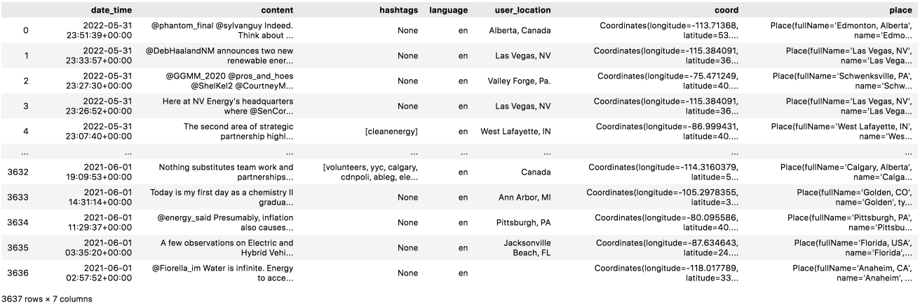

Figure 2: DataFrame of scraped tweets

|  |  |  |  |  |  |
| --- | --- | --- | --- | --- | --- |
| **date_time** | **content** | **language** | **user_location** | **coord** | **place** |
| 2022-05-31 23:51:39+00:00 | @phantom_final @sylvanguy Indeed. Think about it, years from now, new EVs should be made with nearly 100% recycled batteries. Combined with energy generated from renewable sources, and it is clear how personal transportation's impact on the the environment will be greatly reduced. | en | Alberta, Canada | Coordinates(longitude=-113.71368, latitude=53.395531) | Place(fullName='Edmonton, Alberta', name='Edmonton', type='city', country='Canada', countryCode='CA') |
| 2022-05-31 23:33:57+00:00 | @DebHaalandNM announces two new renewable energy initiatives at NV Energy on Tuesday afternoon, including new renewable energy offices that will streamline permitting for projects. Story coming. https://t.co/5bg8X49Mq2 | en | Las Vegas, NV | Coordinates(longitude=-115.384091, latitude=36.129459) | Place(fullName='Las Vegas, NV', name='Las Vegas', type='city', country='United States', countryCode='US') |

Table 3: Sample of scraped tweets from the US

## 3.2 Data Understanding

Upon looking through the collected tweets, it was found that the field ‘user_location’ is unreliable for our analysis as it contains metadata that can be falsified. This field contains the location that users have on their profile but they can enter anything they want. Some users entered locations like ‘Planet Earth’ or ‘I am lost’ as their profile location. It was verified, however, that the fields ‘coord’ and ‘place’ are accurately geotagged according to the location that was queried and did not contain any missing geotags. Hence, we will use the data from ‘coord’ and ‘place’ for the geospatial portion of analysis in the later stage. The data in these two fields, however, still have to be cleaned. The extracted data comes in a lengthy string as shown in Table 3 above. Based on the example of US data in Table 3, data in the ‘place’ column contains information regarding the city, state, and the country where the tweet was made. This information is stored as one long string, which has to be split based on the relevant keys to derive the information we need about each tweet. Furthermore, we have to take a different approach when splitting data from the US and Europe because US data should be aggregated at the state/city level, whereas Europe data will be aggregated by country.

Upon further inspection, the ‘content’ field which is the tweet content contains some irrelevant data such as user mentions, URLs, or unwanted characters such as HTML ampersand formatting (&amp;). The data in this field will have to be cleaned at the data preparation stage.

For the next part of data understanding, we will be looking at the volume of scraped tweets. The number of geotagged tweets in the 6 datasets from June 1, 2021, to June 1, 2022 amounted to 18,216 tweets. The breakdown of tweets in each dataset is shown in Table 4. In terms of overall volume, there were less tweets from Europe compared to the US in the same period. For US tweets, clean energy had the highest volume with 5,317 tweets and green energy had the lowest volume with 2,138 tweets. In Europe, renewable energy had the highest tweet volume with 3,689 tweets and clean energy tweets had the lowest volume with 1,091 tweets.

|  |  |
| --- | --- |
| **Dataset** | **Number of tweets** |
| Renewable Energy tweets from the US | 3,637 |
| Clean Energy tweets from the US | 5,317 |
| Green Energy tweets from the US | 2,138 |
| Total tweets from the US | 11,092 |
| Renewable Energy tweets from Europe | 3,689 |
| Clean Energy tweets from Europe | 1,091 |
| Green Energy tweets from Europe | 2,344 |
| Total tweets from Europe | 7,142 |
| **Total number of tweets** | **18,216** |

Table 4: Number of tweets in each dataset

## 3.3 Data Preparation

### 3.3.1 Removing Duplicates

The first part of data preparation was to combine the tweet data by their region as we wish to analyse public sentiment towards low-carbon energy sources as a whole rather than as 3 separate sources. This means that the 6 datasets will be combined to become 2 datasets (one for tweets in Europe and the other for tweets in the US). The combination was done by concatenating the 3 DataFrames for each region using pandas. There were several duplicate tweets as some tweets contain more than one of the searched keywords and was scraped accordingly. For instance, a tweet may contain both ‘renewable energy’ and ‘clean energy’ and thus will be present in 2 datasets. It was found that there were a total of 960 duplicates and the duplicated data was removed from the dataset. Table 5 shows the breakdown of tweets after removing duplicates in the dataset.

|  |  |
| --- | --- |
| **Dataset (After removing duplicates)** | **Number of tweets** |
| Renewable Energy tweets from the US | 3,439 |
| Clean Energy tweets from the US | 5,093 |
| Green Energy tweets from the US | 2,027 |
| Total tweets from the US | 10,559 |
| Renewable Energy tweets from Europe | 3,524 |
| Clean Energy tweets from Europe | 991 |
| Green Energy tweets from Europe | 2,182 |
| Total tweets from Europe | 6,697 |
| **Total number of tweets** | **17,256** |

Table 5: Breakdown of tweets after removing duplicates

### 3.3.2 Cleaning Tweet Texts

The second part of data preparation involves cleaning the content in each tweet. Tweets often contain information that have no meanings or do not add value to the analysis and, therefore, should be removed. Such things include the mentioning of other users (‘@user’), quoted retweets (‘RT: …’), URLs, unwanted characters, or whitespace, which may affect the sentiment analysis later on. Emojis and emoticons were kept as some sentiment analysis algorithms, such as unsupervised lexical-based methods, are able to handle and provide a score for emojis and emoticons. Likewise, punctuations and capitalisations were not changed as certain sentiment analysis algorithms are able to consider emphasis through punctuations or capitalisations when generating a sentiment score. Hashtags are also kept as users often use words with hashtags as part of their sentences. A function was written using Regular Expression on Python to check if a tweet contains certain patterns in the text and to replace or remove that pattern accordingly. Table 6 shows the specific Regular Expression patterns to search for and the outcome of finding said patterns – whether the pattern is removed or replaced with another string. The function was then run on all tweets in both datasets and stored in a new column for cleaned tweets. Table 7 displays a few tweet contents before and after they are cleaned.

|  |  |  |
| --- | --- | --- |
| **Purpose of Regular Expression** | **Text pattern to search** | **Outcome** |
| Search for quoted retweets | RT @[\w]*: | Remove |
| Search for mentioned users | (@[A-Za-z0-9_]+) | Remove |
| Search for URLs | https?://[A-Za-z0-9./]* | Remove |
| Search for HTML ampersand formatting | &amp; | Replace with ‘and’ |
| Search for whitespaces | ‘ ‘ | Remove |

Table 6: Regular Expression search pattern and outcome of search

|  |  |
| --- | --- |
| **Tweet content before cleaning** | **Tweet content after cleaning** |
| ‘TONIGHT: There are only a few hours left to pass a comprehensive #climate bill that prioritizes equity, jobs, &amp; justice! @DonHarmonIL, @RepChrisWelch - nearly 50 legislators won’t vote for an energy bill without a #FossilFreeFuture. #CleanEnergy #twill https://t.co/Z0D6yooaTw’ | ‘TONIGHT: There are only a few hours left to pass a comprehensive #climate bill that prioritizes equity, jobs, and justice! , - nearly 50 legislators won’t vote for an energy bill without a #FossilFreeFuture. #CleanEnergy #twill’ |
| ‘@energy_said Presumably, inflation also causes fossil fuel prices to rise. So, inflation should be unimportant when comparing a new FF power plant to a new renewable plant.\nThey must be talking about comparing new renewable to existing FF.’ | ‘Presumably, inflation also causes fossil fuel prices to rise. So, inflation should be unimportant when comparing a new FF power plant to a new renewable plant. They must be talking about comparing new renewable to existing FF.’ |

Table 7: Tweet content before and after cleaning

### 3.3.3 Cleaning Location Data

The last part of data cleaning involves cleaning the data in the ‘place’ field. As aforementioned in *3.1 Data Understanding*, this field contains location data, which is important for the analysis at the later stage. For US data, we want to derive the state where each tweet was made as it will facilitate spatial analysis of tweets. Regular expression was used to split the string in the ‘place’ column to derive the city and state of origin. Table 8 shows the output of extracting the city and state, where the ‘place’ column shows the original scraped data; ‘city_state’ contains the city and state where the tweet was made; and ‘state’ shows the further extraction of the state from data in ‘city_state’.

|  |  |  |
| --- | --- | --- |
| **place** | **city_state** | **state** |
| Place(fullName='Houston, TX', name='Houston', type='city', country='United States', countryCode='US') | Houston, TX | TX |
| Place(fullName='Redding, CA', name='Redding', type='city', country='United States', countryCode='US') | Redding, CA | CA |
| Place(fullName='Delaware, USA', name='Delaware', type='admin', country='United States', countryCode='US') | Delaware, USA | USA |

Table 8: Output after extracting city and state from US data

Based on the third row in Table 8, it is evident that some city and states from the original ‘place’ column are incorrect. In this case, Delaware was wrongly categorised as the city and USA was wrongly categorised as the state. However, Delaware is actually a state and USA should be the country of origin. Upon further inspection of all US tweet data, there were 1,457 of such cases where the state was wrongly categorised as cities and the state was wrongly categorised as USA. It is likely that there were issues with pinpointing the city of origin when geotagging and Twitter may have just input the state as the city instead. Hence, all these cases, where states were categorised as cities, were manually mapped to their respective state codes. For instance, if ‘city_state’ was ‘Delaware, USA’, then ‘state’ would be manually mapped to the state code of Delaware, ‘DE’, instead of ‘USA’. For such cases, ‘city_state’ would be left as it is because this column will not be used for analysis; only the ‘state’ column will be necessary for spatial analysis. Furthermore, tweets in the US dataset also comprised tweets from Canada. These tweets were removed as we require only tweets from the US in spatial analysis.

The same method was used on Europe tweet data, but this time we need the country code instead of the state code. The string in the ‘place’ column was split and Regular Expression was used to identify the country code within the string. Table 9 shows the output after extracting the country and country code from tweets in Europe.

|  |  |  |
| --- | --- | --- |
| **place** | **country** | **country_code** |
| Place(fullName='Neston, England', name='Neston', type='city', country='United Kingdom', countryCode='GB') | United Kingdom | GB |
| Place(fullName='Nøtterøy, Norge', name='Nøtterøy', type='city', country='Norway', countryCode='NO') | Norway | NO |
| Place(fullName='Wexford, Ireland', name='Wexford', type='city', country='Ireland', countryCode='IE') | Ireland | IE |

Table 9: Output after extracting country and country code from Europe data

The same issue of wrongly categorising states as cities did not occur in Europe data. However, there were 41 tweets where the country of the tweet was ‘United States’. These 41 cases were removed in order not to hinder the spatial analysis.

# Chapter 4: Modelling and Analysis/Discussion

## 4.1 Modelling

The method of sentiment analysis applied in this study is “Valence Aware Dictionary for Sentiment Reasoning (VADER)” – an unsupervised, lexicon-based model to classify tweet sentiments. According to the study by Ballestar et al. (2020), VADER is a robust rule-based model which does not require training in advance and is computationally efficient – which is ideal in our study. VADER works by mapping lexical features which are labelled according to their semantic orientation to return a metric score for the sentiment of the tweet. It not only returns if a tweet is positive or negative, but also how positive or how negative the tweet’s sentiment is – also known as sentiment polarity. The score returned by VADER ranges from 1 (strongly positive) to –1 (strongly negative). VADER is specifically attuned to handle sentiments expressed in social media content and it was found in prior studies to outperform even individual human scoring (Ballestar et al., 2020). For instance, it is able to factor emojis, punctuations, capitalisations, and repeated words, thus, making it ideal for this study as we are using Twitter data. Table 10 provides an illustration of how the score generated by VADER varies according to different emotional cues commonly used in social media content.

|  |  |
| --- | --- |
| **Example: Sentence** | **VADER compound score** |
| “grabngoinfo.com is a fantastic website for step by step machine learning tutorials.” | 0.5574 |
| “grabngoinfo.com is a FANTASTIC website for step by step machine learning tutorials.” | 0.652 |
| “grabngoinfo.com is a FANTASTIC FANTASTIC FANTASTIC website for step by step machine learning tutorials.” | 0.933 |
| “grabngoinfo.com is a FANTASTIC FANTASTIC FANTASTIC website for step by step machine learning tutorials!” | 0.936 |

Table 10: VADER score for different emotional cues (Amy, 2021)

After VADER is applied, it returns the probabilities – ranging from 0 to 1 – that a tweet is negative, neutral, and positive. The model then generates a compound score, which is a final sentiment score ranging from –1 to 1, based on these probabilities. As with all models, there is a likelihood of erroneous classifications, which was also encountered in the study conducted by Dahal et al. (2019). In both studies by Dahal et al. (2019) and Ballestar et al. (2020), manual classification was involved to reduce the number of false negatives and false positives. This was done by expanding the ‘neutral’ threshold – for instance, Dahal et al. (2019) classified tweets that had scores between –0.25 to 0.25 as neutral. The same methodology for reducing wrong classifications is adopted in this study as well. Figure 3 below is a flowchart which depicts the process of applying VADER on a tweet and how each tweet’s sentiment is subsequently classified.



Figure 3: VADER process and sentiment classification

Table 11 below shows the negative, neutral, positive probabilities and the compound score generated by VADER as well as the sentiment classification on some tweets in the dataset. As shown in the second tweet in Table 11, the compound score returned by VADER, albeit negative, is classified as neutral because it falls within the neutral threshold of –0.25 to 0.25.

|  |  |  |  |  |  |
| --- | --- | --- | --- | --- | --- |
| **Tweets from Dataset** | **Negative** | **Neutral** | **Positive** | **Compound** | **Sentiment** |
| Do a little reading. Abbot is opposed to green energy and doing his best to kill it. And loss of power was mostly a failure of gas and nuclear plants. | 0.248 | 0.601 | 0.151 | -0.6124 | Negative |
| Water is infinite. Energy to access it can be renewable. Land is abundant. Every single argument against golf makes zero sense. | 0.106 | 0.805 | 0.089 | -0.1027 | Neutral |
| WE NEED A MANHATTEN PROJECT TO CLEAN UP PLASTICS. TO ME IT REPRESENTS OUR GREATEST GREEN ENERGY PROBLEM. PLASTICS ARE FOUND IN OUR SEA LIFE, SOME PLACES IT HAS EFFECTED CURRENTS, AND TEMPERATURES. | 0.066 | 0.713 | 0.221 | 0.7430 | Positive |

Table 11: VADER output and sentiment classification

One limitation of using VADER is that the dictionary contains only English words and will score foreign language tweets with a neutral sentiment score of 0 (Dahal et al., 2019). This is because VADER uses a lexicon-based approach for Natural Language Processing, which means that it is unable to identify new entities that are not in the existing lexicon. As VADER’s lexicon only contains English words, texts in foreign language cannot be identified and VADER cannot return the semantic orientation of the texts in such tweets. Hence, returning a sentiment score of 0 for tweets in foreign languages. However, as only tweets in English were collected and used in this study, this limitation will not adversely affect the analysis.

## 4.2 Volume Analysis

For the analysis, we first look at the distribution of tweet data volume over the duration of one year for each region, starting with US tweet data. Figure 4 shows the volume of clean, green, and renewable energy tweets in the US throughout the one year period. From the weekly distribution of tweet volume in the US shown in Figure 4, a significant spike in volume can be seen around late February and early March in 2022. This is the period when the Russia-Ukraine war intensified, likely sparking discussions around the impending energy crisis and spikes in energy prices. As the collected tweets were related to low-carbon energy sources, we can infer that the discussions stemming from the Russia-Ukraine war also created significantly more discussions around renewable energy, clean energy, and green energy. Russia is a major player in global energy markets as the world’s largest gas exporter and one of the largest oil exporters as a member of OPEC+. Hence, the spike in volume suggests that users could be raising awareness about the need for diversifying energy sources or discussing about alternative energy sources to consider as a result of the war.

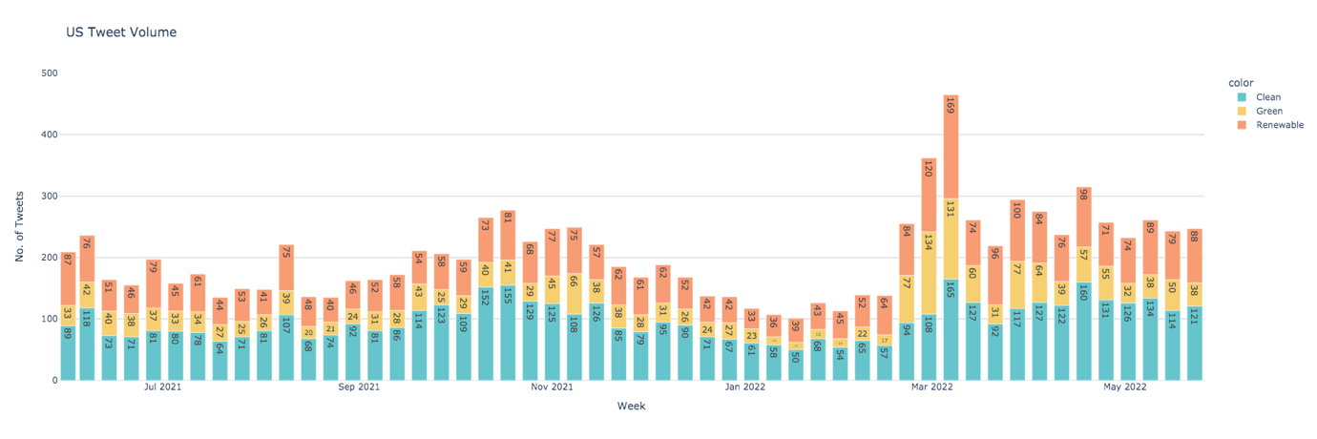

Russia-Ukraine War

Figure 4: Tweet volume of low-carbon energy tweets in the US

Figure 5 below shows the weekly distribution of low-carbon energy tweet volume in Europe throughout the one year period. Similar to tweet data from the US, there was a spike in tweet volume in Europe, but at the end of October 2021 instead. This is in line with the UN Climate Change Conference in Glasgow (COP26) which took place from October 31, 2021, to November 12, 2021. This suggests that significantly more discussions were sparked in Europe due to the COP26, possibly regarding the outcomes and expectations of the parties.

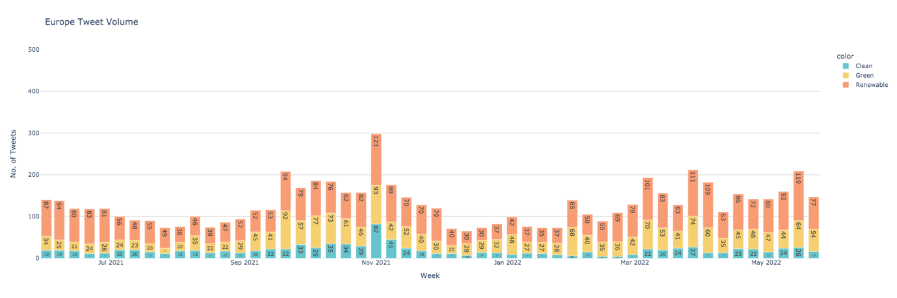

COP26

Figure 5: Tweet volume of low-carbon energy tweets in Europe

To gain a better understanding of the contribution of tweet volume, we broke down tweet volume by state and by country in the US and in Europe respectively. The volume contributed by each state/country is plotted in a choropleth for easy visualisation. Figure 6 shows a screenshot of an interactive choropleth of tweet volume from each state in the US and Table 12 shows the top 5 states with the highest tweet volume. California (shaded in dark purple in Figure 6) contributed the highest volume over the period, making up 13.17% of all US tweets.

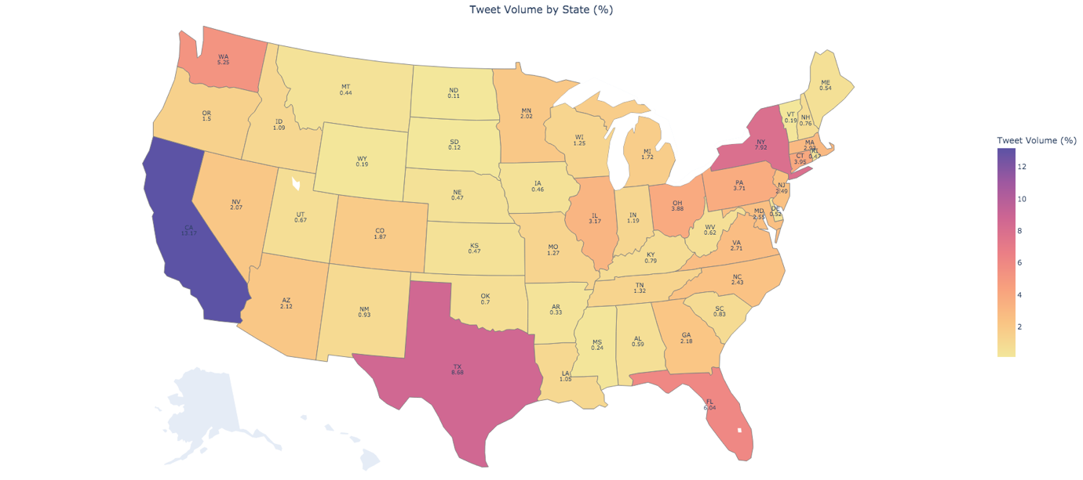

Figure 6: Tweet volume by US state

|  |  |
| --- | --- |
| **State** | **Proportion of Tweets (%)** |
| California | 13.17 |
| Texas | 8.68 |
| New York | 7.92 |
| Florida | 6.04 |
| Washington | 5.24 |

Table 12: Top 5 states with highest tweet volume

For Europe, Figure 7 is a screenshot of an interactive choropleth showing tweet volume according to each European country and Table 13 shows the top 5 countries with the highest tweet volume. Tweets from the United Kingdom (shaded in dark purple in Figure 7) made up the majority of volume of Europe tweets (55.07%), followed by Ireland (shaded in orange in Figure 7) which made up 19.5% of tweets from Europe. The high volume of tweets from the United Kingdom and Ireland is likely a result of scraping only tweets that were in English – thus omitting tweets in major European languages such as German, French, and Spanish.

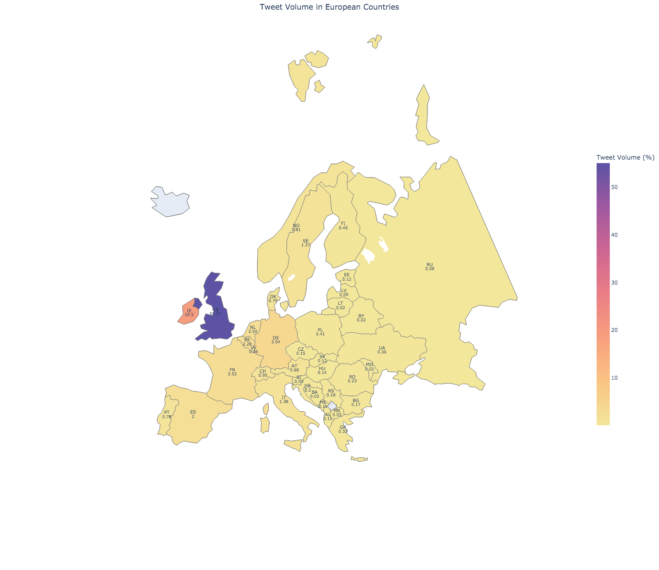

Figure 7: Tweet volume by European countries

|  |  |
| --- | --- |
| **Country** | **Proportion of Tweets (%)** |
| United Kingdom | 55.07 |
| Ireland | 19.50 |
| Germany | 3.94 |
| France | 2.52 |
| Belgium | 2.28 |

Table 13: Top 5 European countries with highest tweet volume

## 4.3 Sentiment Analysis

### 4.3.1 Sentiment Proportion

Looking at the proportion of sentiments for overall tweet data, it can be seen in Figure 8 below that the large majority of tweet sentiments were positive. For all low-carbon energy tweets in the US and Europe in the period, 76.1% were positive, 14.7% were neutral, and 9.25% were negative.

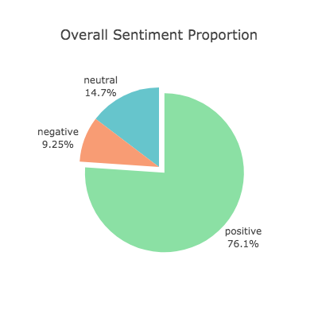

Figure 8: Sentiment proportion of all tweets

The breakdown of sentiment proportion in the US and in Europe is shown in Figure 9 below. The large majority of tweets in both regions were positive – 76.4% and 75.5% of tweets were positive in the US and Europe respectively. The proportion of positive tweets in both regions is similar, which indicates that the large proportion of positive tweets was not skewed or dominated by any particular region in the period. Apart from positive tweets, however, Europe had a larger proportion of neutral tweets compared to the US; the US had a larger proportion of negative tweets than Europe.

|  |  |
| --- | --- |
|  |  |

Figure 9: Sentiment proportion in the US and in Europe

### 4.3.2 Word Frequency

To understand topics of importance to the public, we used word frequency as an indication of frequent words in tweets. This was done on positive and negative sentiment tweets in both the US and Europe to understand what keywords were often mentioned in positive tweets and negative tweets in each region. The reason for using word frequency instead of hashtags to indicate frequent discussion topics is because not all tweets contain hashtags, meaning that we will be omitting words if they are not used as hashtags. Whereas hashtag texts can still be factored in generating word frequency, thus, all texts will be included when calculating frequency. This is to ensure that no potentially important words are missed out in this part of the analysis. To get the frequency of words, we first remove stop words from tweet texts along with the words ‘clean’, ‘green’, ‘renewable’, ‘energy’, ‘cleanenergy’, ‘greenenergy’, and ‘renewableenergy’. This is because our scraping query included these words and all tweets in the dataset would contain at least one of these words. For each analysis, we generated a word cloud of the 100 most frequent words and will be reviewing tweets with the 3 most frequent words. Starting with positive words in the US, Figure 10 shows the word cloud of the 100 most frequent words and Table 14 shows the 5 most frequent words used as well as the frequency of these words.

Although the most frequent word is ‘will’ which appeared 1,024 times in the dataset, a preliminary check showed that ‘will’ in most tweets was used as a modal verb rather than a noun. Hence, did not add value to the analysis. The second most frequent word is ‘solar’ where a large number of tweets with the word ‘solar’ were raising awareness for solar energy, for instance, the benefits and feasibility of using solar energy as an energy source. These tweets covered adoption at an individual level, such as installing solar panels, and at a larger scale, like garnering support for petitions for legislators to make solar energy affordable and easily accessible. There were also tweets that were discussing the adoption of solar energy for crypto mining processes. The words ‘climate’ and ‘fuel’ appeared 707 times in positive tweets in the US. The word ‘climate’ was used a lot in discussions surrounding President Joe Biden’s climate and energy bill and how it can positively drive decarbonisation. There were also a lot of tweets advocating for positive climate. For the word ‘fuel’, most of the tweets were users sharing their opinions on using fossil fuels compared to low-carbon energy sources in human activities. There were also tweets discussing fuel prices and inflation.



Figure 10: Word Cloud – US positive tweets

|  |  |
| --- | --- |
| **Word** | **Frequency** |
| will | 1,024 |
| solar | 984 |
| climate | 707 |
| fuel | 707 |
| need | 692 |

Table 14: 5 most frequent words – US positive tweets

Figure 11 shows the word cloud of the 100 most frequent words and Table 15 shows the 5 most frequent words for negative tweets in the US. Similar to positive tweets in the US, ‘will’ is the most frequent word but will be omitted in the analysis as it was used more often as a modal verb than a noun. The word ‘oil’ is the second most frequent word with 153 appearances in US negative tweets. Tweets with ‘oil’ were largely surrounding the negative environmental repercussions caused by the operations of big oil companies. The word ‘need’ was used mainly to advocate the need to transition to low-carbon energy sources. Negative tweets in the US with the word ‘climate’ was mainly seen in discussions about the climate crisis.



Figure 11: Word Cloud – US negative tweets

|  |  |
| --- | --- |
| **Word** | **Frequency** |
| will | 158 |
| oil | 153 |
| need | 117 |
| climate | 116 |
| fuel | 109 |

Table 15: 5 most frequent words – US negative tweets

Figure 12 shows the word cloud of the 100 most frequent words and Table 16 shows the 5 most frequent words for positive tweets in Europe. The most frequent word ‘solar’ appeared 1,115 times and was mainly used in tweets advocating the effectiveness of solar power and photovoltaic technology. Many users shared how much energy is being produced from solar panels they had installed. It was also discovered that the following words ‘Ireland’, ‘ClimateAction’, and ‘EnergyTransition’ were trending hashtags used in similar tweets. This points to the effectiveness of Twitter in anchoring discussion topics among users with common interests through the use of hashtags.



Figure 12: Word Cloud – Europe positive tweets

|  |  |
| --- | --- |
| **Word** | **Frequency** |
| solar | 1,115 |
| Ireland | 802 |
| ClimateAction | 777 |
| EnergyTransition | 724 |
| home | 700 |

Table 16: 5 most frequent words – Europe positive tweets

For tweets in Europe with negative sentiments, Figure 13 shows the word cloud of the 100 most frequent words and Table 17 shows the 5 most frequent words. The word gas is the most frequent word with 85 appearances. Tweets with the word ‘gas’ comprised various topics but was most commonly used in discussions around gas prices due to the energy crisis – which is also the reason for the fifth most frequent word, ‘price’. There were also discussions about alternative energy sources due to the gas price crisis. The next most frequent word ‘will’ shall be skipped for similar reasons mentioned above. Almost all discussions with the word ‘fuel’, which appeared 60 times, was around the damaging effects of fossil fuel for energy and advocating for alternative low-carbon energy sources. Similarly, the word ‘need’ was largely used to discuss the importance of energy transition. The word ‘price’ also revealed some interesting tweets which largely blamed governments and policymakers for the energy crisis and skyrocketing prices. Tweets also showed discontent with prices for green energy adoption and users being unable to adopt low-carbon energy sources as a result.



Figure 13: Word Cloud – Europe negative tweets

|  |  |
| --- | --- |
| **Word** | **Frequency** |
| gas | 85 |
| will | 83 |
| fuel | 60 |
| need | 59 |
| price | 54 |

Table 17: 5 most frequent words – Europe negative tweets

### 4.3.3 US Analysis by State

Sentiments in the US was further broken down and aggregated by states and it was found that all states had an average sentiment score that was greater than 0. Table 18 and Table 19 shows the top 5 states with the highest and lowest sentiments respectively. Based on the manual classification threshold from -0.25 to 0.25, only the state of South Dakota falls within the ‘neutral’ class, and all other states are classified as ‘positive’.

|  |  |
| --- | --- |
| **State** | **Average Sentiment** |
| Vermont | 0.754 |
| Wyoming | 0.613 |
| Arkansas | 0.591 |
| Utah | 0.555 |
| Oklahoma | 0.549 |

Table 18: Top 5 states with highest sentiment

|  |  |
| --- | --- |
| **State** | **Average Sentiment** |
| South Dakota | 0.201 |
| New Mexico | 0.313 |
| Maine | 0.329 |
| Kansas | 0.340 |
| North Dakota | 0.349 |

Table 19: Top 5 states with lowest sentiment

Figure 14 is a screenshot of an interactive choropleth showing the average sentiment of each US state. The state with the highest sentiment is Vermont, which is in dark blue, and the state with the lowest sentiment is South Dakota in dark red. It is important to reiterate that all states had scores above 0. The scale in Figure 14 is meant to contrast the minor differences showing how positive the sentiment of each state is.

Figure 15 shows the electoral map of the 2020 US Presidential Election results for a visual comparison of sentiments against political standing of each US state. Table 20 shows the sentiments of blue states versus red states. It can be seen that tweets from blue states have an average sentiment of 0.46, which is only slightly more positive than red states with an average sentiment of 0.448. As the average sentiments of blue and red states are relatively similar, we are unable to identify any correlation between political standing and sentiments towards low-carbon energy sources.

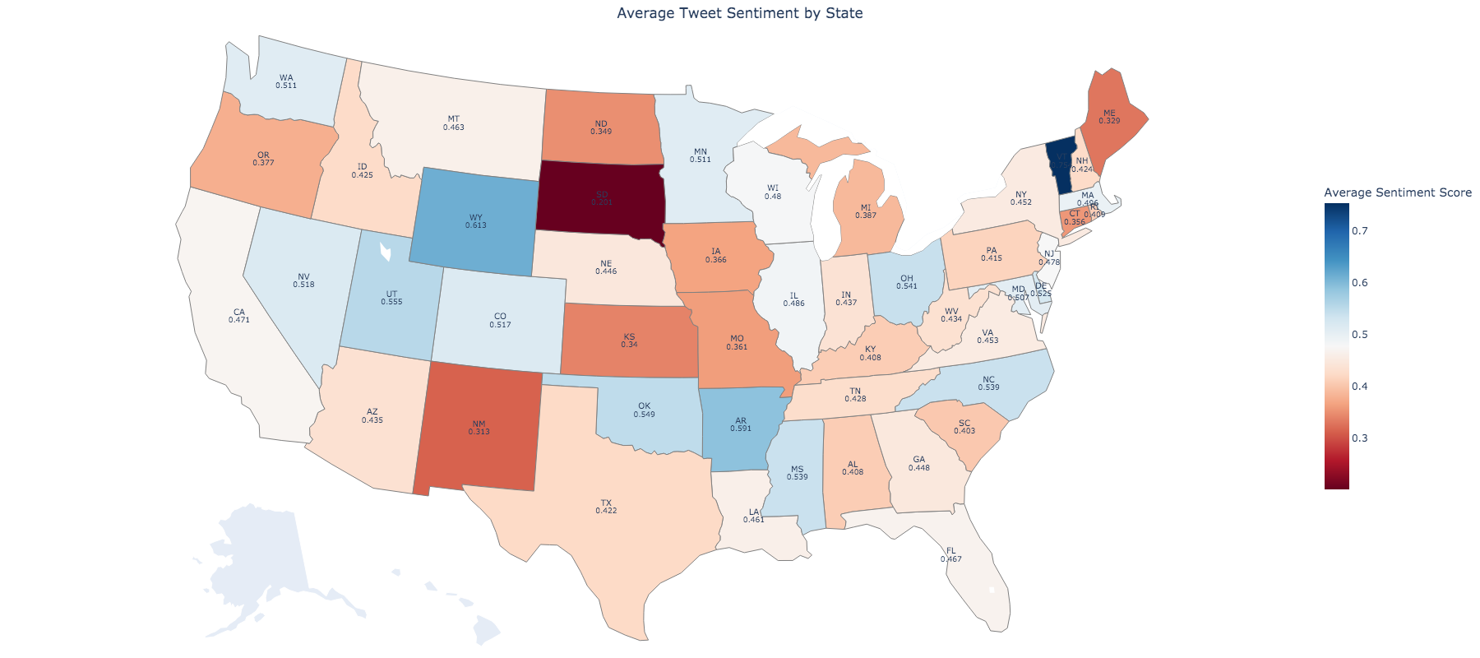

Figure 14: Choropleth showing average sentiment of US states



Figure 15: 2020 US Presidential Election results (CNN, n.d.)

|  |  |  |
| --- | --- | --- |
|  | **Blue States (Democratic)** | **Red States (Republican)** |
| **Average Sentiment** | 0.460 | 0.448 |

Table 20: Average sentiment by political landscape

### 4.3.4 Europe Analysis by Country

A similar analysis is done on Europe where sentiments were aggregated by country. Table 21 and Table 22 shows the top 5 European countries with the highest and lowest sentiments respectively. Apart from the Republic of Slovenia, the average score of all European countries is greater than 0. Based on the manual classification threshold from -0.25 to 0.25, the Republic of Slovenia, Isle of Man, and Turkey fall within the ‘neutral’ class. Hence, there are no countries with negative sentiments.

|  |  |
| --- | --- |
| **Country** | **Average Sentiment** |
| Lithuania | 0.945 |
| Monaco | 0.858 |
| Moldova | 0.822 |
| Luxembourg | 0.787 |
| Republic of Belarus | 0.746 |

Table 21: Top 5 countries with highest sentiment

|  |  |
| --- | --- |
| **Country** | **Average Sentiment** |
| Republic of Slovenia | -0.084 |
| Isle of Man | 0.039 |
| Turkey | 0.240 |
| Malta | 0.354 |
| Gibraltar | 0.372 |

Table 22: Top 5 countries with lowest sentiment

Figure 16 is a screenshot of an interactive choropleth showing the average sentiment of each European country. The country with the highest sentiment is Lithuania, which is in dark blue, and the country with the lowest sentiment is the Republic of Slovenia in dark red. Once again, it is important to note that apart from the Republic of Slovenia, the average score of all other European countries is greater than 0. The scale in Figure 16 is meant to contrast the subtle differences showing how positive the sentiment of each state is.

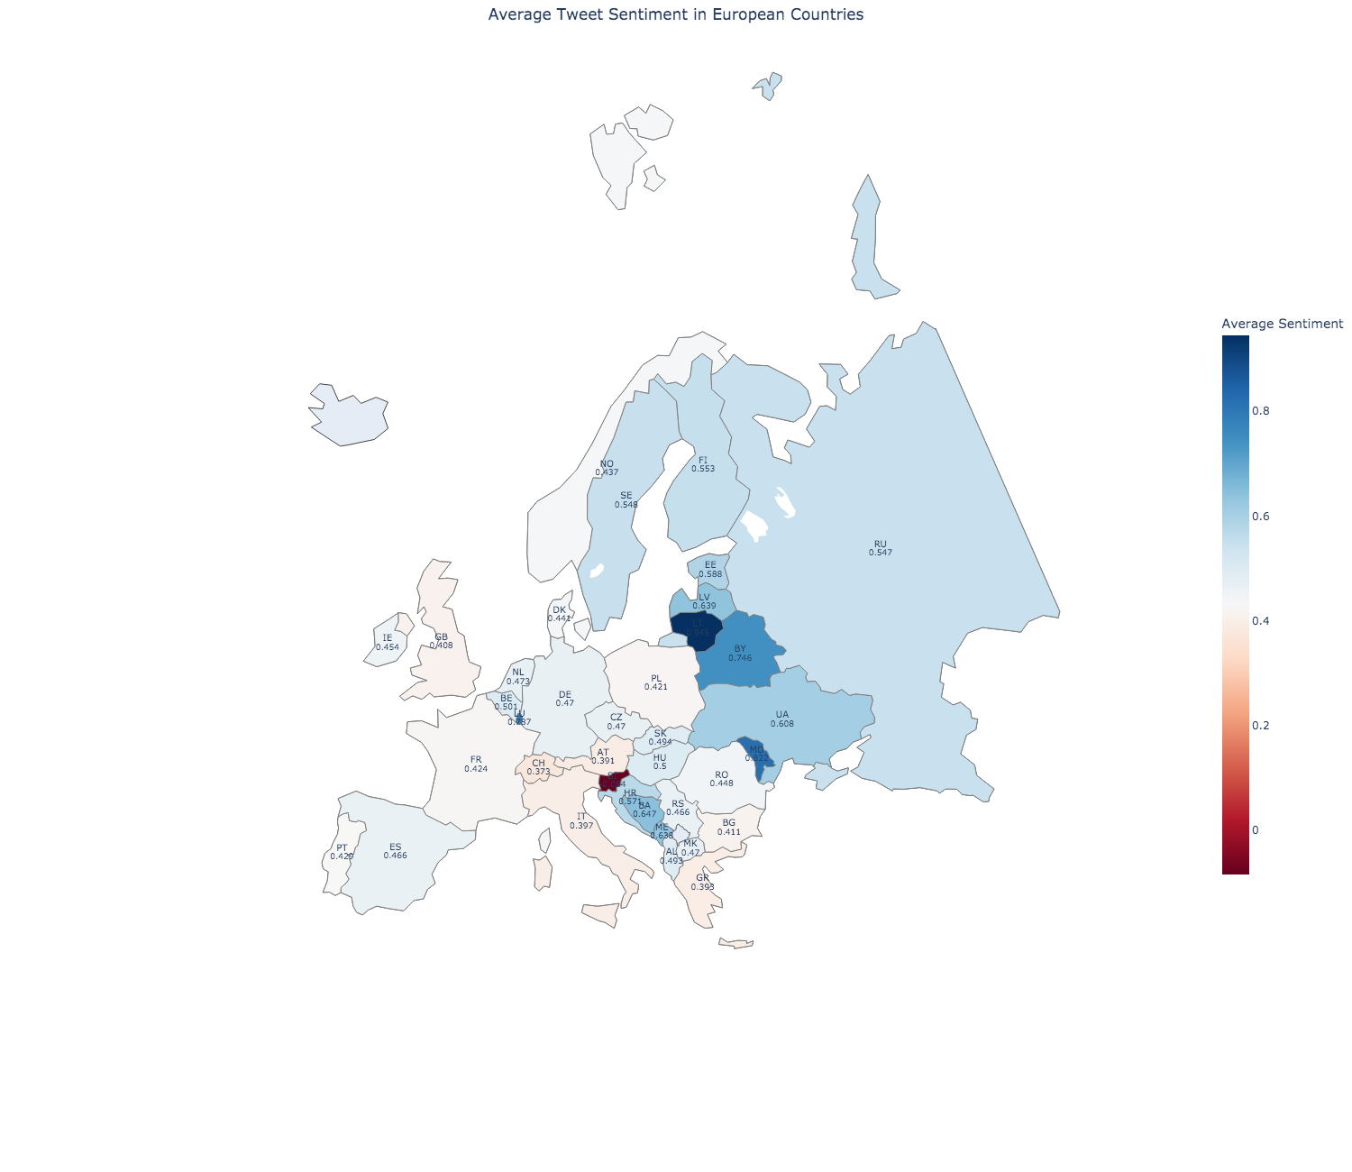

Figure 16: Choropleth showing average sentiment of European countries

# Chapter 5: Recommendations

The following are some recommendations for future work, given more time. Firstly, it will be to expand the sources for data collection. As found in the study by Kim et al. (2021), data from Twitter may not be fully representative due to the demographics of the platform. Twitter users are younger and more politically liberal, hence would tend to favour low-carbon energy development and possibly inflate the sentiment scores in this analysis compared to the true sentiments (Kim et al., 2021). For future works, we can consider expanding data collections to include more platforms such as Facebook and Reddit. Furthermore, differing adoption rates of internet and social media in some countries may cause a selection bias. This is likely so for lower-income and older populations or segments with lower education (Zhang et al., 2022). This is especially applicable to Europe where internet usage is higher amongst aged segments in Northern Europe compared to Southern Europe (Zhang et al., 2022). Zhang et al. (2022) also named another limitation of data collection using social media, which is missing crucial details about participants such as their social and demographic attributes. This limitation is also applicable to this study as such details may help uncover valuable insights on varying demographics and their perceptions of low-carbon energy sources. Thus, it is worth considering adding conventional data collection methods in future works to have more details about participants and capture opinions of older populations with no access to the internet.

Secondly, to expand and include more languages in the analysis. European languages were not factored in this study due to linguistic limitations of both the researcher and the model. This caused a bias especially in Europe data as tweets in major European languages were not collected. Consequently, the United Kingdom, where English is the main spoken language, made up the vast majority of tweets from Europe. Dahal et al. (2019) faced a similar limitation and suggested translating tweets or adopting a supervised sentiment analysis technique that can handle multiple languages if there is enough data in foreign languages. It is recommended to take on the suggested approach for future work if there are sufficient computational and time resources.

Lastly, another recommendation to improve on for future work is to extend the time frame of the analysis. The data used in this study spans over a one-year period. Extending the period where data is collected will allow for a more in-depth analysis on how tweet volume and sentiments evolve over longer periods of time.

# Chapter 6: Conclusion

The objective of this study is to analyse public sentiment towards low-carbon energy sources from a geospatial and temporal perspective, by using Twitter as a data source. The analysis is based on tweets collected from Europe and the US over a one-year period. We first conducted volume analysis where we found that spikes in tweet volume was in correspondence to significant real-world events such as the COP26 and the Russia-Ukraine war.

We then conducted sentiment analysis using VADER and found that public sentiment towards low-carbon energy sources in the US and Europe is positive overall. We also provided a comprehensive overview of the geographical variation in public sentiment across states and countries. Looking at the geospatial analyses, we can see that the sentiment in certain states and countries are more positive than others. This also allowed us to introduce and compare political factors and how it may cause differing sentiments towards low-carbon energy sources. However, the differences in sentiments were minor, which suggests that regardless of political views, the people in each region share similar sentiments towards low-carbon energy sources.

We also generated frequent keywords derived from positive and negative tweets, which suggest topics of high importance to the public. In the United States, the word ‘climate’ was used a lot in positive discussions surrounding President Joe Biden’s climate and energy bill and how it can drive decarbonisation. In Europe, the word ‘price’ appeared frequently in negative tweets with discussions on high gas prices and high prices for green energy. States or countries that wish to gain public support for energy transition can consider looking into these areas of high importance when addressing concerns or making key decisions. This information can aid governments and organisations like the UN to design better adoption strategies and low-carbon emission policies or initiatives.

Lastly, this study provides empirical evidence that social media platforms like Twitter can be utilised to gain easy access to international, valuable, and real-time information. This is especially so when there is a lack of formal statistics or when it is impractical or costly to use conventional data collection methods.

**(9,208 words)**

# References

Amy. (2021). *TextBlob vs. VADER for Sentiment Analysis Using Python*. Towards AI. Retrieved September 8, 2022, from https://pub.towardsai.net/textblob-vs-vader-for-sentiment-analysis-using-python-76883d40f9ae

Ballestar, M. T., Cuerdo-Mir, M., & Freire-Rubio, M. T. (2020). The Concept of Sustainability on Social Media: A Social Listening Approach. *Sustainability*, *12*(5), 2122. https://doi.org/10.3390/su12052122

CNN. (n.d.). *Presidential Election Results and Electoral Map 2020*. Retrieved September 10, 2022, from https://edition.cnn.com/election/2020/results/president

Dahal, B., Kumar, S.A.P., & Li, Z. (2019). Topic modeling and sentiment analysis of global climate change tweets. *Social Network Analysis and Mining*, *9*(1), 24. https://doi.org/10.1007/s13278-019-0568-8

International Energy Agency. (2022). *Russia’s War on Ukraine*. Retrieved August 10, 2022, from https://www.iea.org/topics/russia-s-war-on-ukraine

Kim, S. Y., Ganesan, K., Dickens, P., & Panda, S. (2021). Public Sentiment toward Solar Energy—Opinion Mining of Twitter Using a Transformer-Based Language Model. *Sustainability 2021, 13*(5), 2673. https://doi.org/10.3390/su13052673

Reyes-Menendez, A., Saura, J. R., & Alvarez-Alonso, C. (2018). Understanding #WorldEnvironmentDay User Opinions in Twitter: A Topic-Based Sentiment Analysis Approach. *International Journal of Environmental Research and Public Health*, *15*(11), 2537. https://doi.org/10.3390/ijerph15112537

Taylor, C. (2021). *Dutch court rules oil giant Shell must cut carbon emissions by 45% by 2030 in landmark case*. CNBC. Retrieved October 10, 2022, from https://www.cnbc.com/2021/05/26/dutch-court-rules-oil-giant-shell-must-cut-carbon-emissions-by-45percent-by-2030-in-landmark-case.html

United Nations. (2020). *The UN Secretary-General speaks on the state of the planet*. Retrieved July 29, 2022, from https://www.un.org/en/climatechange/un-secretary-general-speaks-state-planet

United Nations. (n.d.). *What is renewable energy?* Retrieved July 29, 2022, from https://www.un.org/en/climatechange/what-is-renewable-energy

United States Environmental Protection Agency. (2022). *Sources of Greenhouse Gas Emissions*. Retrieved July 29, 2022, from https://www.epa.gov/ghgemissions/sources-greenhouse-gas-emissions

Zhang, Y., Abbas, M., & Iqbal, W. (2022). Perceptions of GHG emissions and renewable energy sources in Europe, Australia and the USA. *Environmental Science and Pollution Research 29*(4), 5971–5987. https://doi.org/10.1007/s11356-021-15935-7